x-ist @ CONTEMPORARY ISTANBUL 14
Booth No: LK401 / x-ist PROJECT SPACE
EKİN SAÇLIOĞLU
“Nummulites and In Search of Monodiella”

"This is the history of a tree, a tree that fascinates us but also makes us uncomfortable; this is because we have not had the chance to enlighten all mysteries related to it. This is the history of our family tree. Its roots- our roots – lead up until that soup that gives life. Life that had a botanical approach for the last two milliamps years; has led to a birth of a mutant, a primal creature; formed of a single cell like the others but diversely had a mouth that could eat and swallow all it wanted and a whip that helped it move and hunt. Our rule had just started.”*

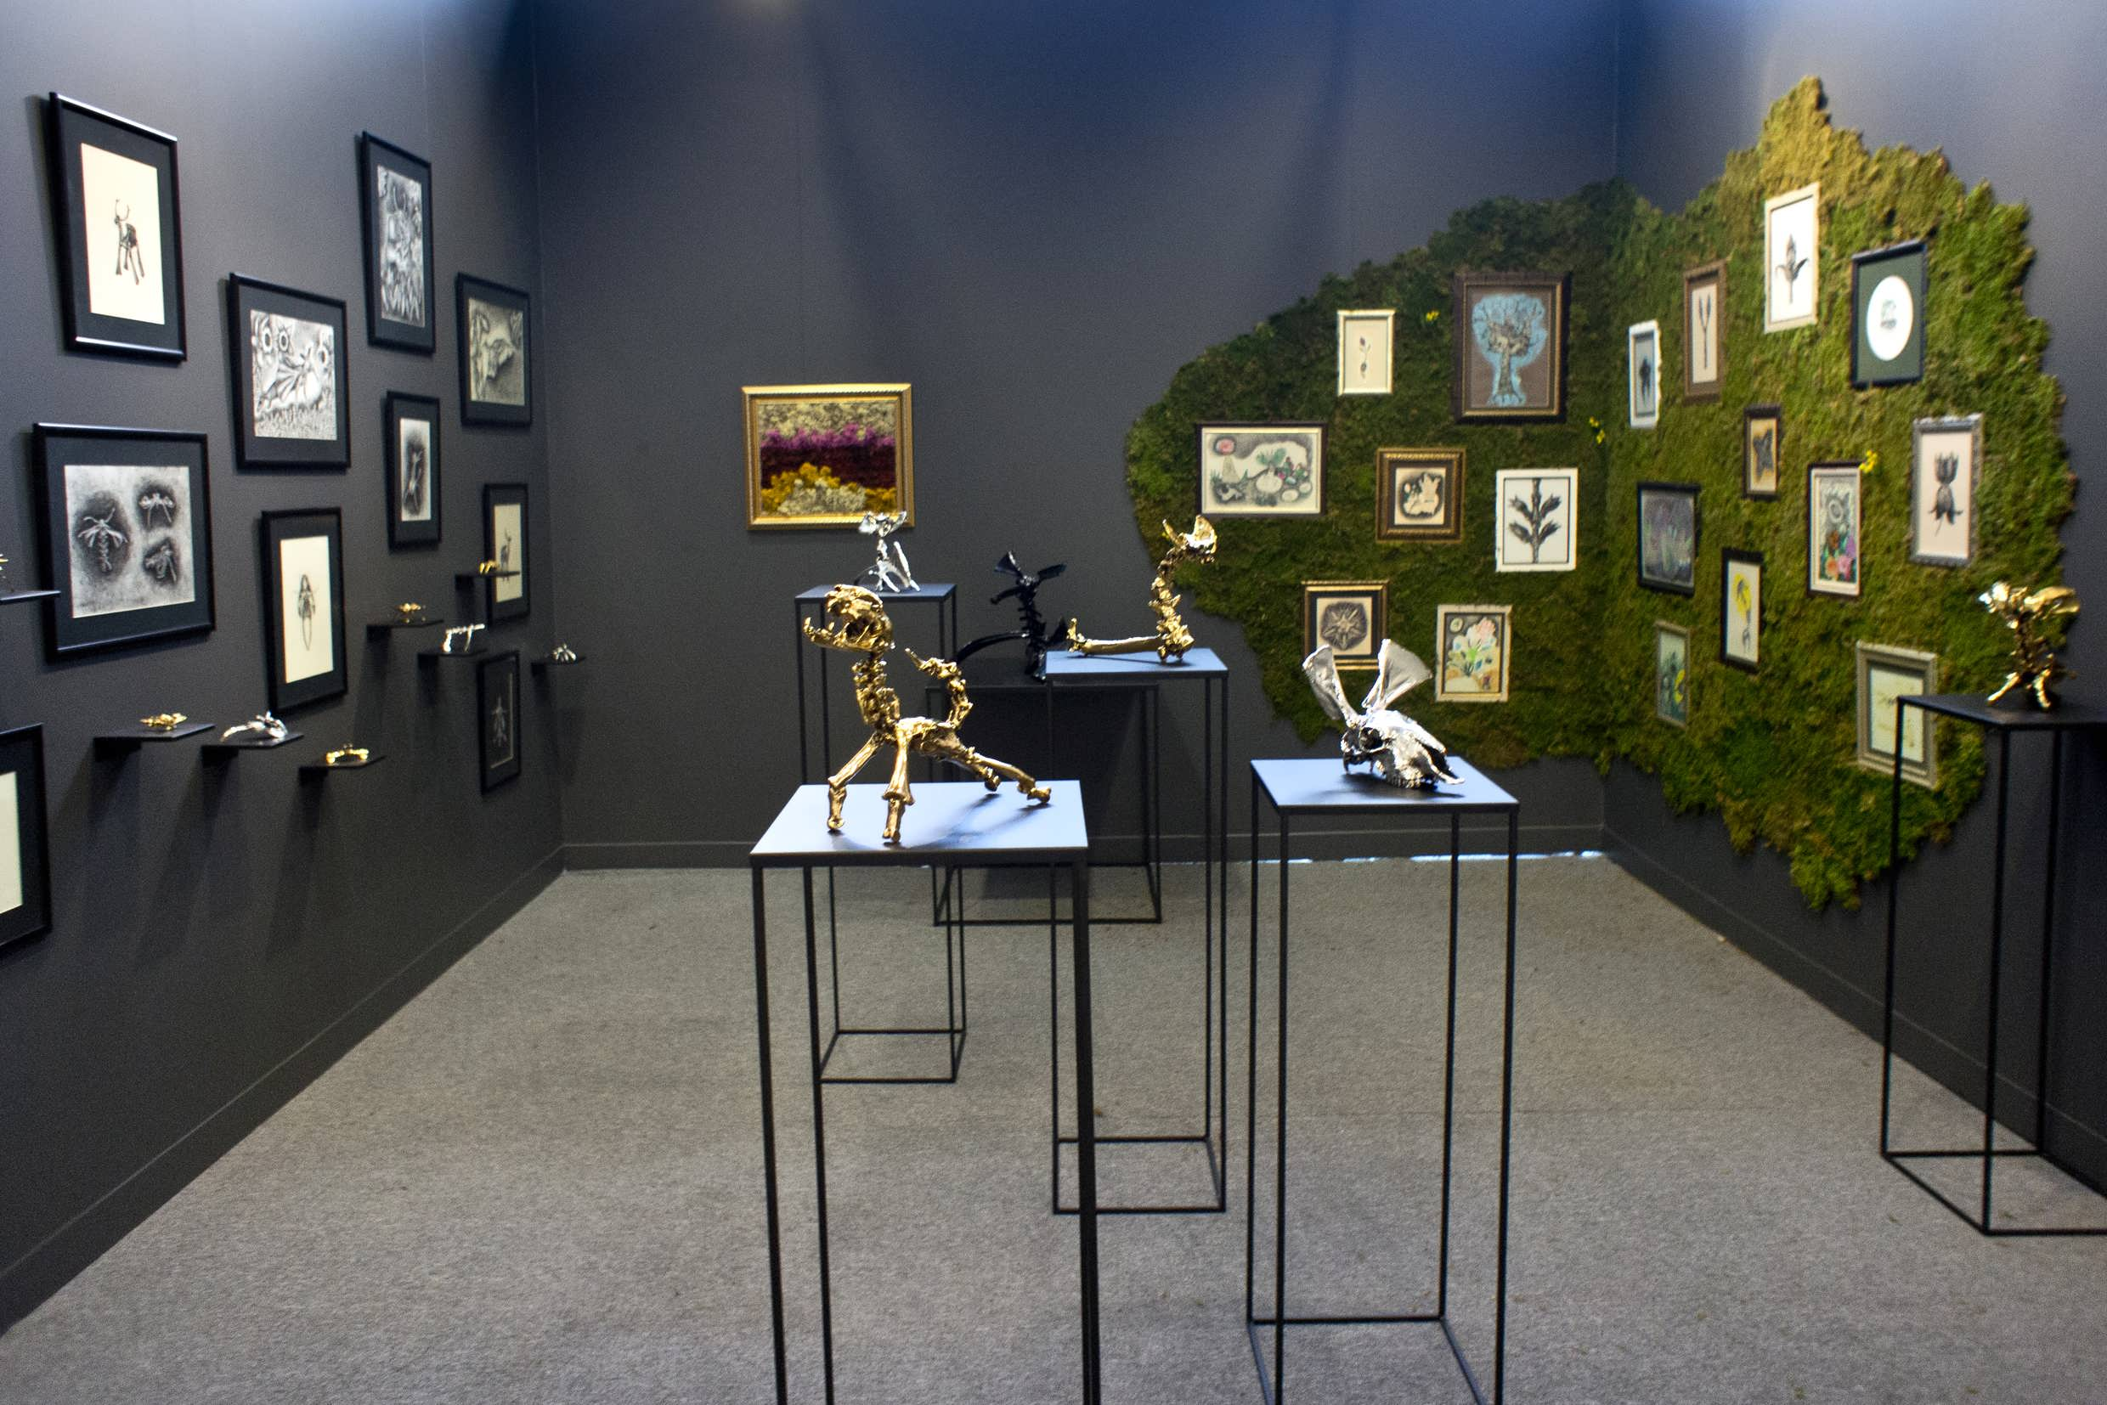

Ekin Saçlıoğlu invites her viewers to a fictional world of animal and plants in her installation in the Contemporary Istanbul Project area. The emergence of animal skeletons made by silver and gold endures itself on the artist’s collection of wisdom teeth from her own dog, bird feathers and cat whiskers that she has been keeping in a toy box since the age of 10.

Bones from horses, sheep, cows, dogs, turkeys and chicken are combined in different ways to form the fictional skeletons of the animals. This might be considered as an emotional stand towards disappearance or a mode of protection…

Saçlıoğlu acts as a scientist of fossils, going back from the fictious skeletons, imagining them alive and thus creating the patterns.

The world of animals is now together with the world of plants. Monod, a piece from the installation of Ekin Saçlıoğlu titled “In Search of Monodiella (Homage to Theodore Monod)” greets us again in the area. Monod, discovered plant called Monodiella in 1940’s at the Sahara desert but then loses track of it. He continues to search for this plant – like a love story triggering hope and dreams – until he dies at the age of 99 in 2001.

A life passionately dedicated to a plant he has only seen once, a life spent dreaming of it, paleontology, trying to write a history of life solely looking at an animal fossil… A fascination due to encountering a species which we thought was alive 65 million years ago, thinking that the seaweed is the ancestors of all of us and animals…

These are what Saçlıoğlu imagines and presents to the viewers… These and many more…

“Nummulites and In Search of Monodiella” awaits its visitors at x-ist’s project space.

*Bitkilerin En Güzel Tarihi, s. 7, Türkiye İş Bankası Kültür Yayınları

For more information please contact Ece Göymen from x-ist.
E. ece@artxist.com T. +90 212 291 77 84 M. +90 537 349 13 27

EKİN SAÇLIOĞLU / İZMİR, 1979
Saçlıoğlu received her graduate and undergraduate degrees from Mimar Sinan University, Painting Department (2005). She continues the Sufficiency in Arts Program in Yıldız Technical University, Faculty of Fine Arts and Design. The artist's first solo show was exhibited in Bir Culture and Arts Center in 2004 (Istanbul). Her solo shows at x-ist were "From a Little Closer" (2005), "Narrative Memory" (2007), "Cat Nap" (2009), "I'm Shocked But I'm not Surprised" (2011) and "Pothole" (2012) were her solo shows in x-ist. Saçlıoğlu's works have been exhibited in many group shows in Austria, Germany, Holland, Sweden and Greece. Some of the shows and fairs she hasAmong the group shows and art fairs Saçlıoğlu participated are: "young expansions" group show (Pera Museum, 2005), Contemporary Istanbul'06, 07, 08, 09, 10, 11, 12 & 13, “Made in Turkey” (Frankfurt, 2008), Art Asia Miami 2008, "450 Million Years of Friendship" (Hafriyat Karaköy, 2009), "Chaotic Metamorphosis" (Proje 4L / Elgiz Museum of Contemporary Art, 2010), "A University Supplementary to this One" (x-ist, 2014), "Dream and Reality" (Istanbul Modern Museum, 2011), Contemporary Istanbul'06, 07, 08, 09, 10, 11, 12 & 13, Start-2009 (14th European Contemporary Art Fair, Strasbourg, France), Vienna Art Fair 2011, Scope Basel 2011, Art Dubai 2012, VIP Art Fair 2012 and Art HK'12 (Hong Kong International Art Fair) and ArtInternational 2014 (Istanbul). Saçlıoğlu took placeSaçlıoğlu's work was in Sotheby's Contemporary Turkish Art Auction in 2010., the group exhibit in Proje 4L / Elgiz Museum of Contemporary Art titled "Chaotic Metamorphosis" in 2010 and in the group shows, "Dream & Reality" at The Istanbul Museum of Modern Art in 2011 and "A University Supplementary to this One" taking place in x-ist in 2014.

